Discovering Personal Genius™

08
Fall
Developing Vocational Themes: Workbook

Cary Griffin & Dave Hammis
Griffin-Hammis Associates, Inc.

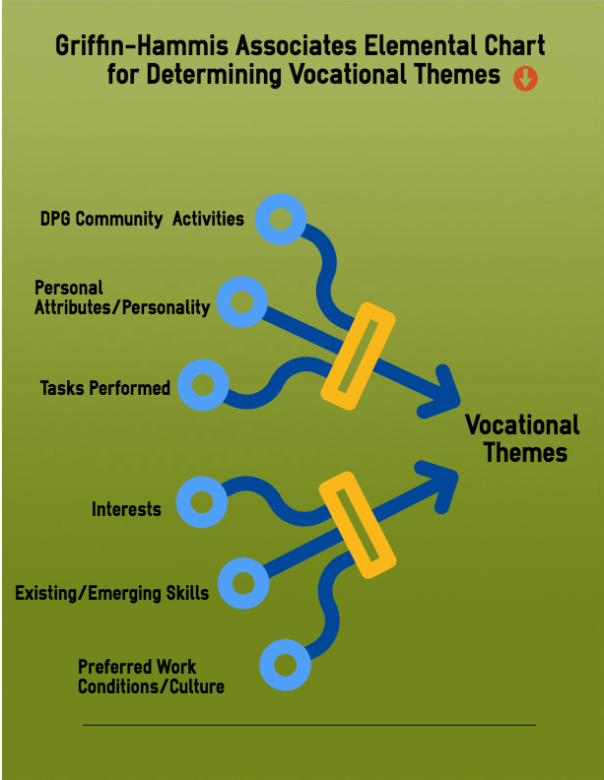
This workbook is a discussion guide for those designing and overseeing Discovering Personal Genius (DPG)™ activities in order to capture critical elements for review by a Customized Employment (CE) team, employment seekers, family members, or any and all folks involved in establishing the vocational plan. CE and DPG are used throughout the U.S. for adults and transition-age youth served by state and local Special Education, Vocational Rehabilitation, Developmental Disability and Mental Health agencies, for Veterans with service-related disabilities, and as part of the Pre-Employment Transition Services (Pre-Ets) mandate of the Workforce Innovation & Opportunities Act (WIOA).
griffinhammis.com
Training in DPG and CE is highly recommended before using this tool.
This workbook supplements the Discovery Staging Record (DSR) (available at griffinhammis.com) and is meant to foster team conversation through the gathering of non-speculative observational data during DPG activities. Discussing the basic elements here, including the individual DPG Activities, the Tasks the individual performs (with and without assistance), their Interests, the Skills they exhibit and those that can be built upon, their personal Attributes and Characteristics, and the Conditions of employment and the Work Cultures providing the best, most natural fit, helps discern the overarching Vocational Themes™. These themes lead us to developing the Lists of Twenty™ places in our community “where the theme and career make sense.”
This workbook is designed for taking notes before and during DPG team meetings; the workbook is not meant to be another report…use it to inform team conversation and actions.
To briefly Recap: Discovering Personal Genius (DPG) is designed to generate no fewer than 3 overarching Vocational Themes. Themes are not job descriptions. They are large umbrella categories that represent an almost unlimited collection of many jobs, environments, skills/task sets, and interests. Too often someone may have an interest in say, flowers. The stereotypical job suggestion is likely to be: Work in a greenhouse or assist at a florist shop. This is very limiting for both the individual and the person charged with managing the career search. By thinking through the theme a bit, supported by DPG evidence of current skills, tasks that can potentially be taught/learned, and interests, as well as work environments and cultures that fit the person, a broader, richer palette of opportunity emerges. By slowing down the process just a bit; performing activities in school, home or community that further illustrate the employment seeker’s resident or emerging skills; engaging a team for ideas; and exploring the community using informational interviews, work try-outs, and/or paid internships, creative options emerge. And while none of us will ever be well versed in the intricacies of even a miniscule number of companies in our communities, the good news is that skills and tasks often transcend industry sectors. Someone who can wash a dish can also wash a helicopter part in a solvent tank. The DPG process pulls us into the community us to see the myriad places where similar skills and ecological fitment are found.

So, someone who helps their parents grow flowers in the family garden demonstrates that they know how to water the flowers, how to prune back dead leaves, and how to hoe weeds. This might mean, although additional Discovery is warranted, that there is an Agricultural Theme. This is not a flower or a plant theme; that would be too narrow. The same skills used in flower gardening are used across many types of agriculture (and within other themes too). The flower garden, after all, is likely the only place the opportunity to learn and perform these tasks has occurred. In fact, DPG challenges us to consider that this might not be an interest of the person at all. Perhaps this is just one of the only activities accessible to the individual. Still, the skills they have (watering, weeding, trimming) are relevant in many work environments and should not be dismissed. The DPG process helps clarify where both interests and skills lie.

If Agriculture is indeed determined to be a Theme through various DPG activities (e.g. a positive work try-out on a weeding team at the Botanical Gardens; trimming trees with in the backyard), then a List of Twenty is developed for that one theme. One strong suggestion when initially exploring Vocational Themes is to put off-limits those jobs and places already considered stereotypical, and instead search out local companies or organizations where people with similar Themes work as trades-people, skilled workers, or artisans; environments where employees are more likely to help co-works learn their trade and new skills and tasks; where a career path may blossom. So, for someone with an emerging Animal Theme, skip the Humane Society, the Pet Store, and the local Kennel, and dig deeper into the fabric of community commerce to find the taxidermist, pet photographer, the horse chiropractor, or the animal vitamin supplement maker. In the case of an emerging Agriculture Theme, abandon the local greenhouse or lawn mowing service and instead seek out the organic goat cheese maker, the beekeepers, and the topsoil recovery services. Interview them, get the details of their operations, and use their supply chains to mine more precise and diverse job development opportunities. A little exploration leads to increased creativity in finding, adapting, and creating new work options. The chart below illustrates the process of interviewing business managers with Themes matching those of an employment seeker and following the supply chains to reveal many possible options in a small community.

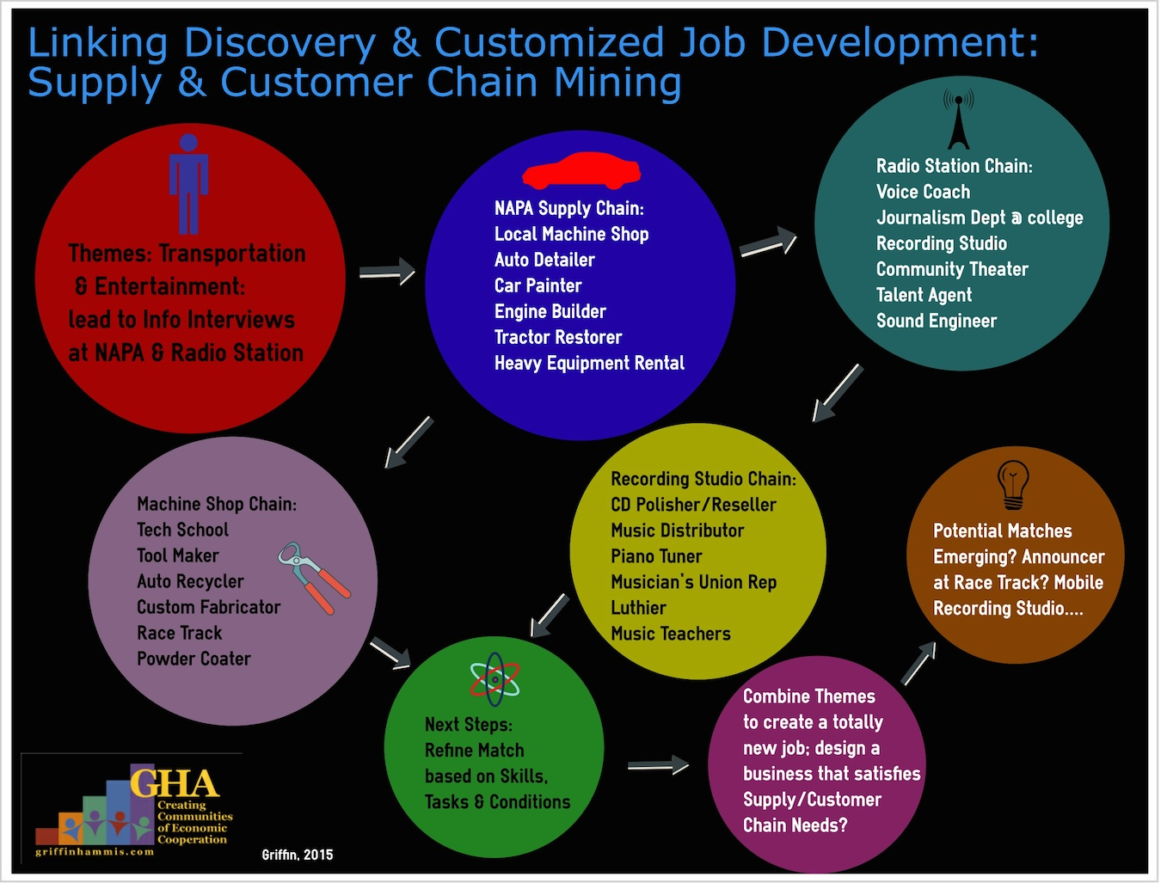

Activities: Briefly detail the DPG Activities observed to date. Discuss why they were chosen and what they revealed. What additional Activities are planned; what additional activities seem warranted?

Activity 1.

Activity 2.

Activity 3.

Activity 4.

Activity 5.

Add additional pages for more Activities…
Tasks: In each of the Activities listed above, please describe the Tasks the individual performed during each (Note that a Task is a series of actions that complete a process: Changing the spark plug in a lawn mower is a task). Discuss the quality of the work performed; teaching & support strategies; where (and where else) these tasks are likely to be valued; new tasks that might be useful to introduce/teach…

Task 1.

Task 2.

Task 3.

Task 4.

Task 5.

Add additional pages for more Tasks…
Skills: For the Tasks listed above, describe the discrete Skills exhibited during each (Note that a Skill is a learned/practiced action that contributes to the completion of a Task: Selecting the correct wrench and setting the gap of the spark plug are both discrete skills used when tuning up the lawn mower). Discuss the level of skill demonstrated; teaching & support strategies; where (and where else) these skills may be valued; new skills that might be useful to teach; and other skills the person has that are obvious or assumed even if not observed…

Skill 1.

Skill 2.

Skill 3.

Skill 4.

Skill 5.

Skill 6.

Skill 7.

Skill 8.

Skill 9.

Add additional pages for more Skills…
Interests: The dictionary defines an interest as an activity that diverts or amuses or stimulates. The steps of DPG are designed to illuminate interests and the analogous skills and tasks involved. Interests are important because being engaged augments skill development, but interests alone are not enough to build a job on; skills, even emerging ones, should also be in evidence. One discovers their interests through repeated exposure with family, friends, educational opportunities, and through personal exploration. Often, for individuals with significant disabilities, choices are limited and what appear as interests are actually the choices of others. List the Interests revealed through DPG observations and conversations. When discussing, match Interests with skills and tasks to help clarify where the career makes sense. Note that Interests often tend to be more like job descriptions than overarching Themes. For instance, an Interest in Flyfishing may lead to the Vocational Theme of Water, or Nature, or Animals, or Sports, or perhaps Problem-Solving….

Interest 1.
Evidence of Interest:

Interest 2.
Evidence of Interest:

Interest 3.
Evidence of Interest:

Interest 4.
Evidence of Interest:

Add additional pages for more Interests…
Personal Attributes: Describe the person, in an objective manner; in terms of personality or behavioral qualities they demonstrate. Be especially careful not to speculate, just report on what’s been observed. Use these attributes as a guide to the type of environment most suitable/preferable for employment, and to determine what works and what doesn’t work for the individual. Punctuality, style of dress, and sense of humor are common attributes. Note that attributes often inform the Conditions of Employment.

Attribute 1.

Attribute 2.

Attribute 3.

Attribute 4.

Attribute 5.

Attribute 6.

Attribute 7.

Attribute 8.

Attribute 9.

Add additional pages for more Attributes…
Conditions of Employment/Work Cultures: These are the considerations for good worksite fitment and include such elements as: pay and benefits expected, preferred work hours, performance of specific tasks and the use of particular skills, regularity and intensity of supervision, etc. In almost any workplace, substantial deviation from the cultural norm of expected traits and performance may inhibit acceptance and inclusion, so knowing the Conditions and Cultural preferences of the individual minimizes bad job match. Note that the discussion again returns to asking: where might folks with similar conditions work; where might such conditions be negotiated; where might this work culture exist in our community?

Condition 1.

Condition 2.

Condition 3.

Condition 4.

Work Culture Element 1.

Work Culture Element 2.

Work Culture Element 3.

Work Culture Element 4.

Add additional pages for more Conditions/Cultural Elements…
Vocational Themes: Based on the evidence collected and discussed so far, what are the solid themes; what are the emerging themes; what information do you need to solidify the list of Three Vocational Themes?

Solid Vocational Themes:
1.
2.
3.

Emerging Vocational Themes:
1.
2.
3.

What information and activities are needed to settle on the final list of Vocational Themes?
1.
2.
3.
4.

Common Vocational Themes: Note this is not all-inclusive, nor is this a checklist. Many of these themes are related and all have varying iterations. For example, employment for someone with a strong Advocacy Theme could range in career areas from Disability, Law Enforcement, and Nursing to Environmental activism, Cheerleading, Highway Safety, and Space Exploration. Combining two or more themes often helps clarify themes, refine career development, and yield strong and unique options for employment. When developing a Vocational Theme, use a word or two that represents all the concepts described in this workbook - Interests, Discovery Activities, Tasks Performed, Skills, Personal Attributes, Conditions/Work Culture – easy to say, not so simple to do! Try not to use words that already represent a work industry or job title, like Healthcare or Nursing, Accounting or Bookkeeping, Carpentry, and Publishing or Writer, unless the individual’s team understands the term to mean more than just that particular industry or job title. The Vocational Theme should help the team develop lists of various businesses where people who share a similar theme work, and not just in a particular type of business or industry. For example, “Construction” could limit the team’s Lists of 20 to just the Construction Industry (building), unless the team understands that the person’s demonstrated interests, skills, and tasks may really reflect “Working With His Hands”; a Hospitality Theme could limit the team to build a List of 20 with businesses from the Food and Beverage Industry, unless the team really understands that the term Hospitality (or perhaps Customer Service) to mean “Welcoming/Caring for Others.” Vocational Themes are not simply taken from a list, but developed for each individual based on the unique aspects of the individual and community. Always use words that to broaden the businesses to be included in the Lists of 20, not narrow them.
Common Vocational Themes
Organization | Children
Agriculture | Advocacy
Construction | Outdoors/Nature
Mechanical | Athletics/Recreation
Transportation | Culinary
Cleanliness | Art
Entertainment | Fashion
Customer Service/Hospitality | History
Military | Politics
Logistics | Travel
Curiosity/Problem-Solving | Mathematics
Science | Water
Religion/Spirituality | Medicine/Health Care
Technology/Computers | Geography
Communications | Leadership

Please use and disseminate this Workbook freely.

Copyright 2011, Griffin-Hammis Associates, Inc. Revised 2017

